Exposure Blend:
Tools of Importance: Quick selection tool

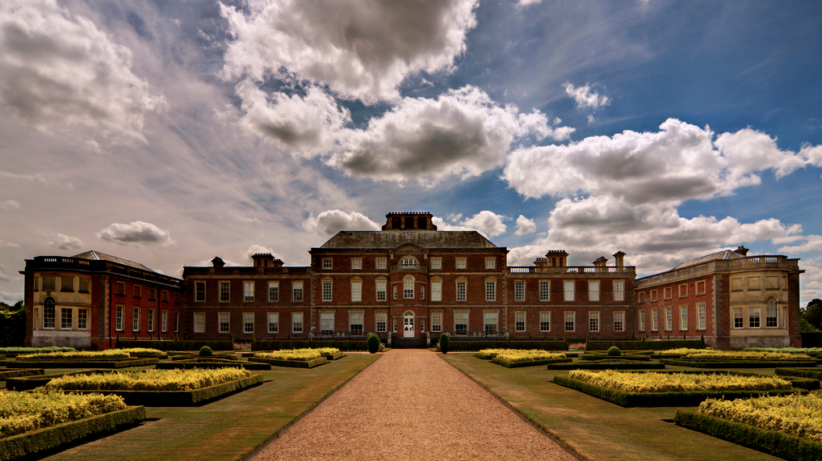

Photo assignment: Use a tripod. Find a subject that is partially over or underexposed. Take one photo that is metered for the highlights and one photo metered for the shadows (without moving the tripod). The final product will be a blend of the two photos so that all parts of the photo are properly exposed.

Bring Exposures Into One File
- Open both photos in Photoshop
- Pull the two tabs apart. Click on the tab and drag down and away to separate the two photos.
- Use the move tool to drag the dark exposure on top of the light exposure

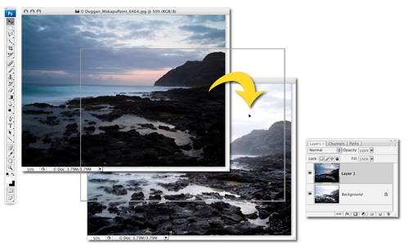

- Select both layers in the layers palette (hold the command key and click on the other layer that isn’t highlighted). Both layers should end up highlighted.
- Go to the edit menu then choose auto-align layers (this will not work if you don’t have both layers selected in the layers palette). Photoshop will line up the two photos.

Add a Layer Mask
- Make sure the top layer in the layer palette is selected
- Click the Add Layer Mask icon at the bottom of the Layers panel
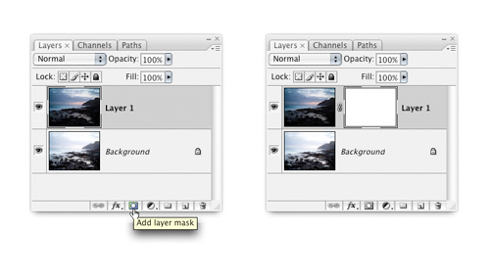

Use the Quick Selection Tool To Select The Area You Want To Paint In
- Choose the quick selection tool
- Choose the “add to selection” setting across the top
- The tool acts like a brush, use the bracket keys to make the brush larger or smaller
- Paint in the area you want to select by clicking and dragging
- If you need to unselect something switch to the “subtract from selection” button
- Click the “refine edge” button in the options bar
- Feather and smooth the edges enough so there won’t be a harsh line where the two photos meet
*This is hard to explain in writing, you may want to watch the screencast in the shared file

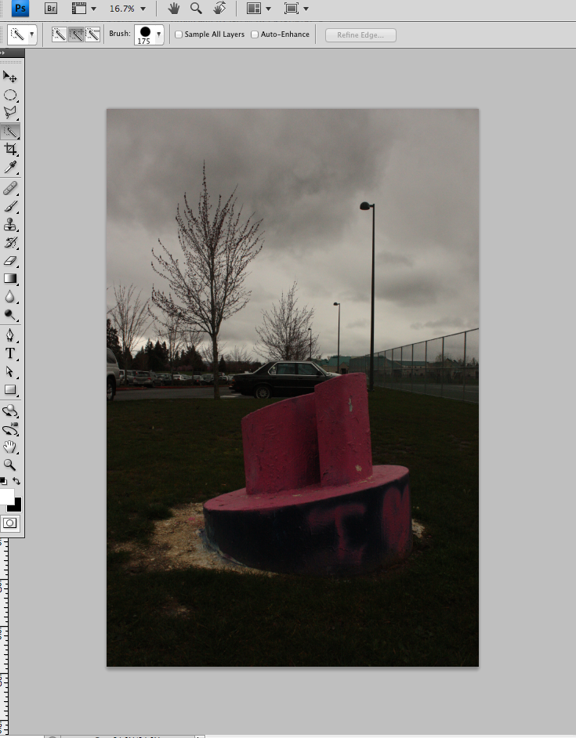

Paint the Layer Mask to Reveal the Lighter Image

- Choose the Brush tool (B) from the Toolbox and set the Foreground color to black.
- In the Options Bar, set the Opacity to 50% and choose a soft-edged brush.
- Check the Layers panel to make sure the layer mask is selected (look for the highlight border around the thumbnail).
- Paint over the image where you want to reveal the lighter tones from the bottom layer (paint multiple strokes to reveal more of the lighter layer).
- You won’t be able to paint past your selection, which means you can work fast and don’t have to be careful around the edges.

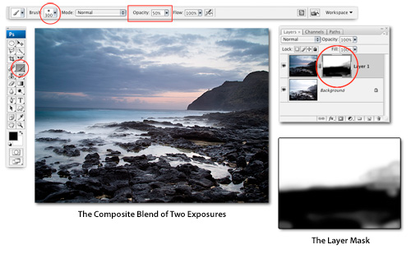

Add levels, curves, & high pass filter & Resize

