Hue and saturation adjustment layer (for color photos):

1. Create a hue and saturation adjustment layer by clicking on the hue and saturation button

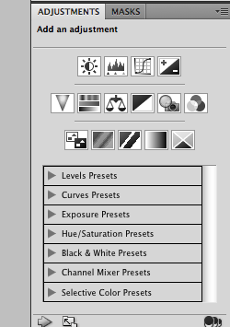

2. Adjust each channel individually or adjust the master control to make colors look vibrant.

