Layer masks
Making changes to only one part of a photo

When you add any adjustment layer a mask automatically comes with it

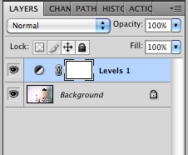

I am going to a levels adjustment layer and the layer mask to lighten only the background of this photo:

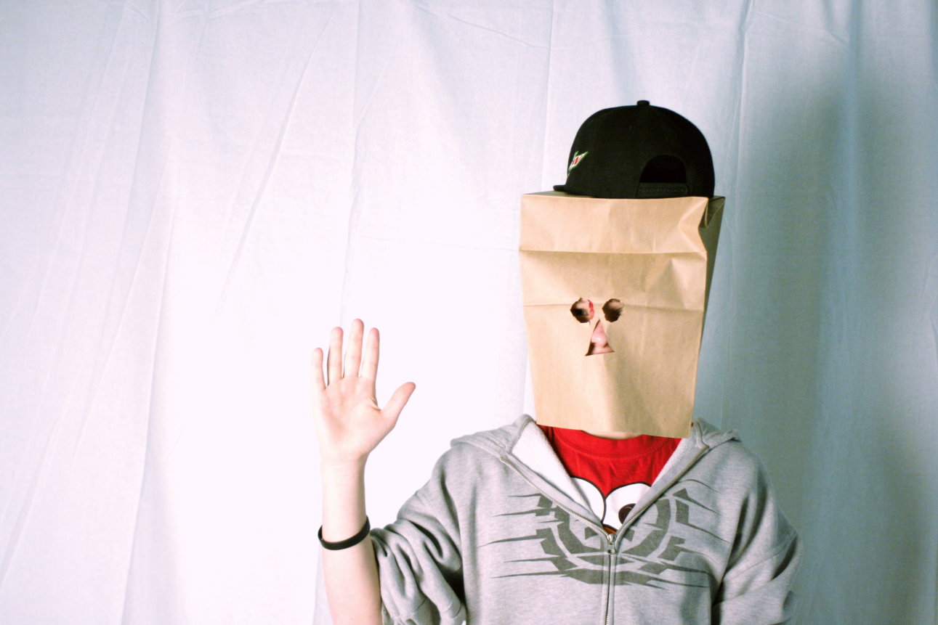

- I use the levels sliders to make the whole photo much brighter. I only pay attention to my background, I ignore the subject for now:

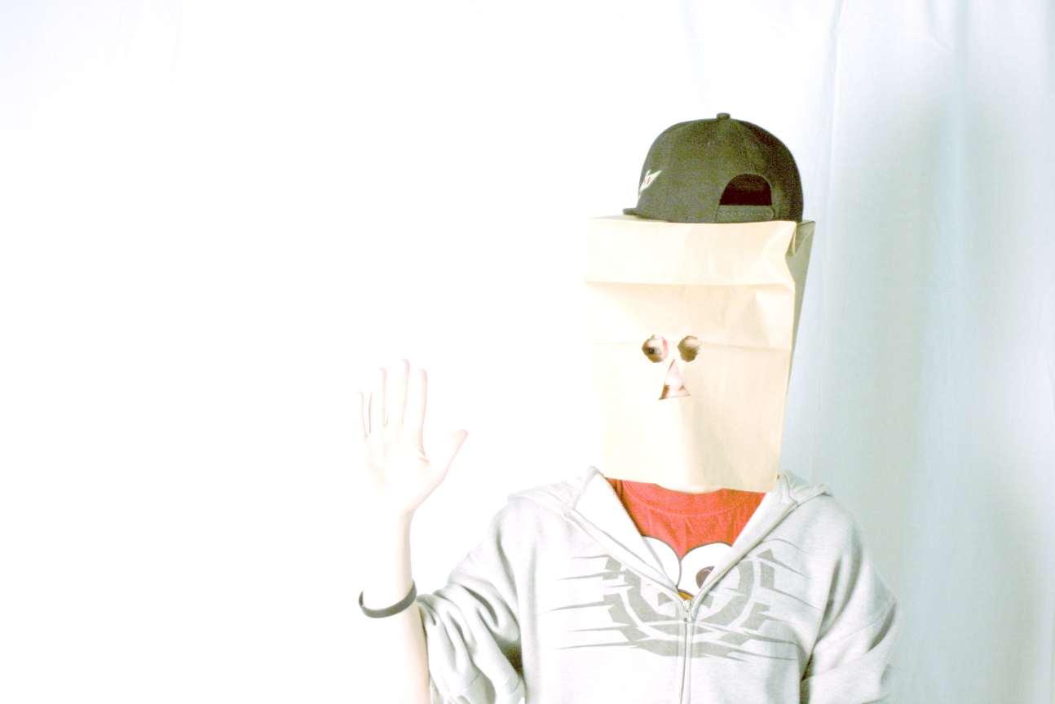

- Command i
inverts the layer mask and hides the adjustment I just made:

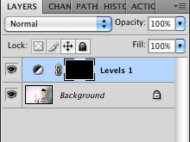

- I choose the paint brush tool at a low opacity and low flow:

- I change the paint color to white:

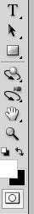

- I change the size of my brush using the bracket keys [ ]

- I use the brush in the adjustment layer using the paint brush. I click and drag over the same spot until it looks like I want it to.

Here I’m halfway finished; I’ve only completed the left side:

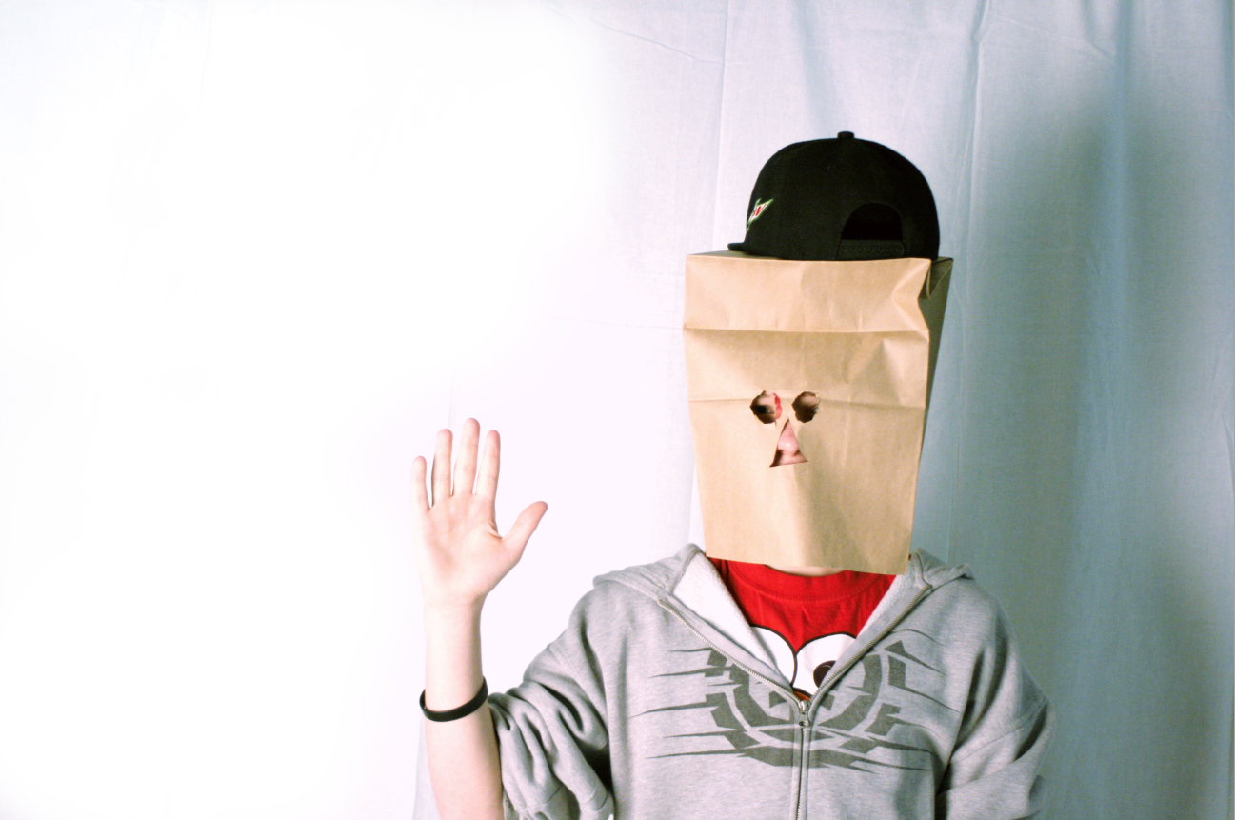

My layer mask icon shows me where I’ve brushed in the adjustment layer (white) and where I haven’t (black):

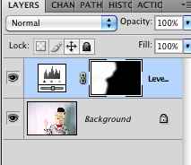

Sometimes the adjustments you are making are subtle. Turn the layer on and off using the eyeball symbol to see the progress you are making.
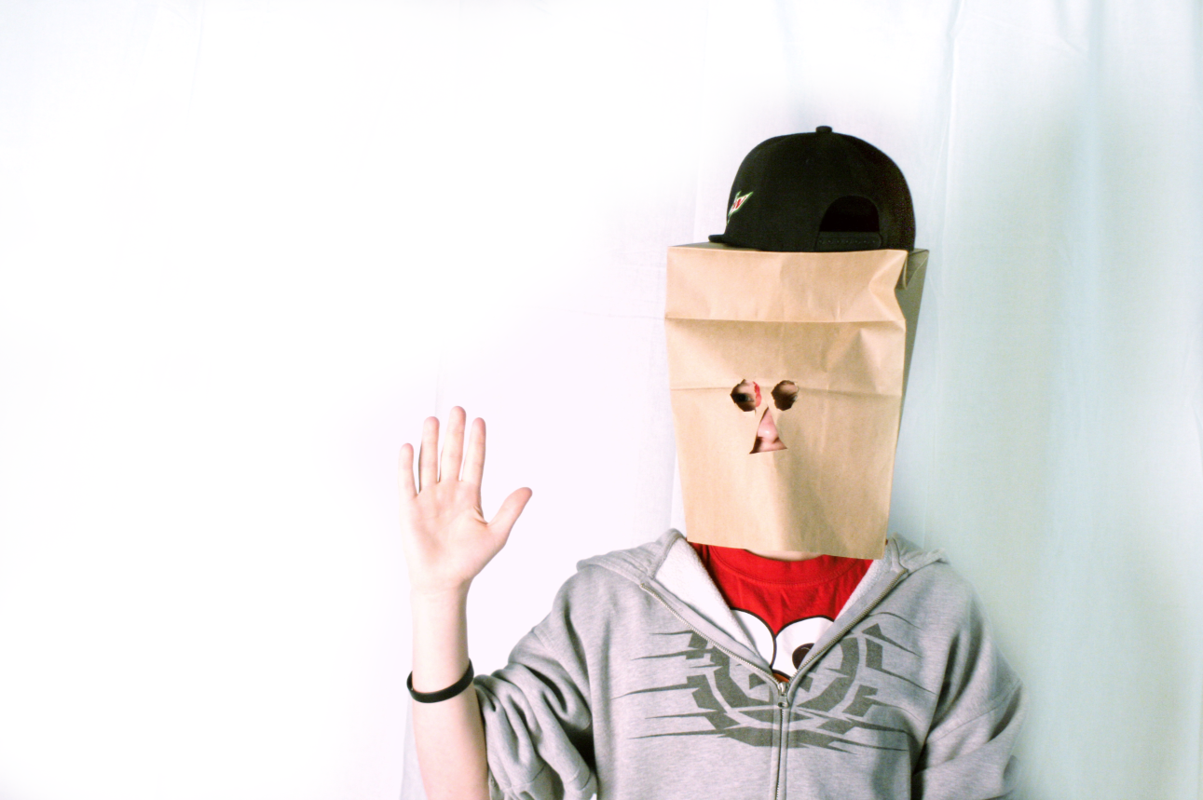
Before: After:

