Selection Merge:
Tools of Importance: ALL

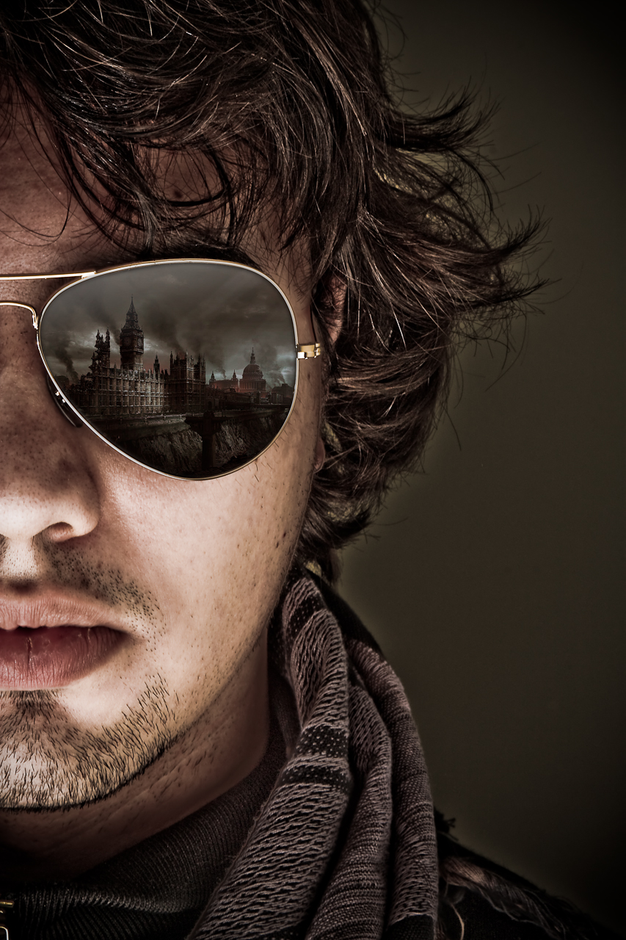

Photo Directions: Take two photos of different scenes that would look cool together and maybe tell a story.

Photoshop Instructions: Same steps as the Exposure Blend (you won’t need to align the layers), but using images of different scenes.

